**Create and Deploy Simple Web Service and Web Service Client in Eclipse**



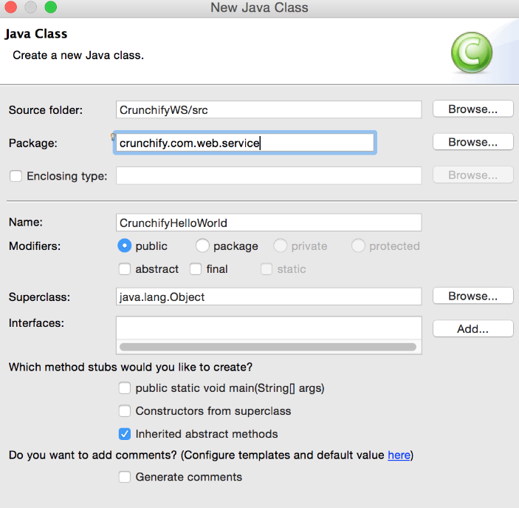

1. Download Axis2 WAR Distribution from below location. ( Version 1.6.2  was the latest at this time )

<http://axis.apache.org/axis2/java/core/download.cgi>

<http://localhost:8080/axis2/services/listServices>

/axis2/services/Version?wsdl

<https://1d8723-automatic-succotash-76gj6wqppprfxxgv-8080.preview.app.github.dev/nonPolice9.01/services/nonPolice9?wsdl>

### JDK Development Kit 20.0.1 download[https://download.oracle.com/java/20/latst/jdk-20_linux-x64_bin.tar.gz](https://download.oracle.com/java/20/latest/jdk-20_linux-x64_bin.tar.gz) ([sha256](https://download.oracle.com/java/20/latest/jdk-20_linux-x64_bin.tar.gz.sha256))